Lesson 5 Demo 4
Integrate Maven with Jenkins

Objective: Install Maven plugin and integrate it with Jenkins

Tools required: Git, GitHub, and Jenkins

Prerequisite: Please ensure you have jenkins installed in order to proceed. In case you don’t have it installed, you can refer to demo 1 of lesson 5 to install jenkins.

Steps to be followed:
- Installing Maven plugin
- Setting the Global Tool Configuration
- Forking a sample repository
- Integrating Maven with Jenkins

Step 1: Installing Maven plugin
  - Open the browser, and go to Jenkins dashboard by typing localhost:8080 in your browser.
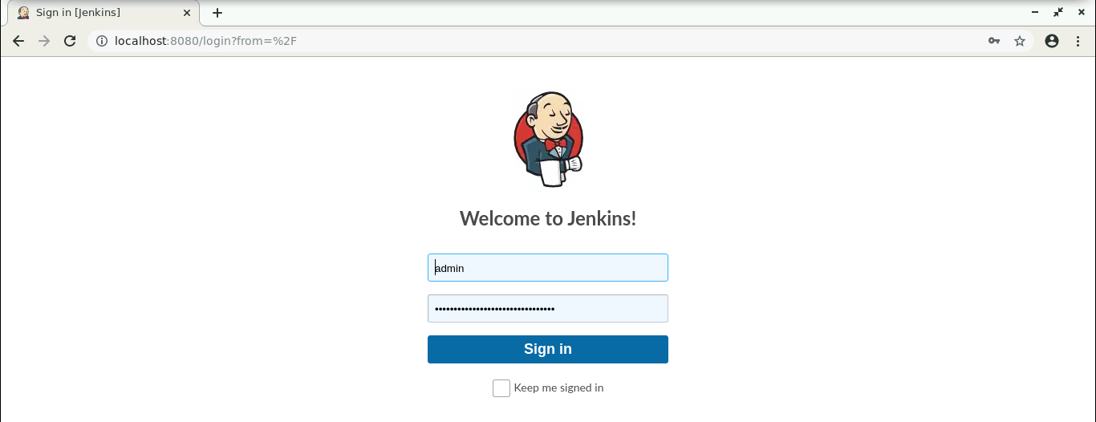

  - Provide the credentials, and click on Sign in.

  - Click on Manage Jenkins. From the list of options, choose Manage Plugins.
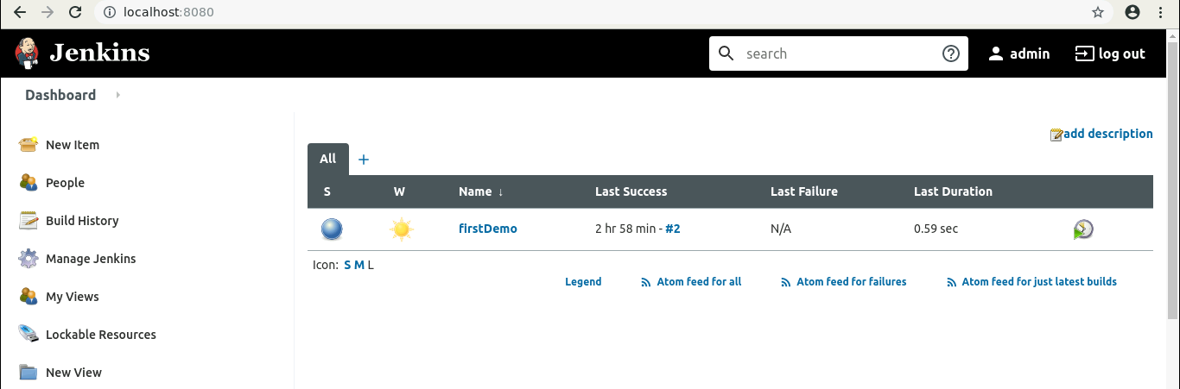

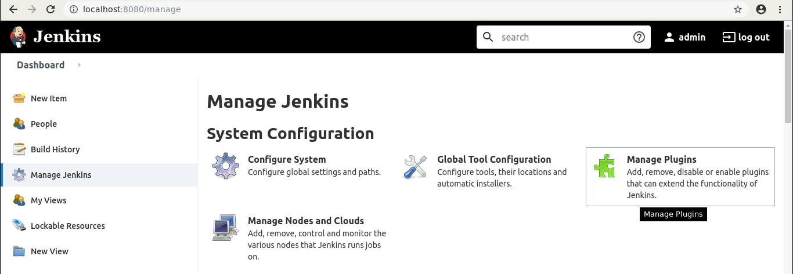

  - Under the Available tab, search for Maven plugin.
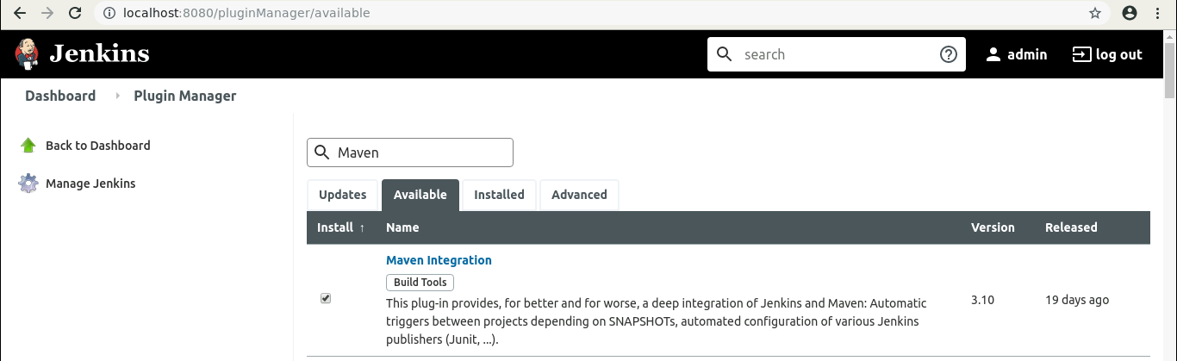

  - Select the checkbox in front of the Maven Integration plugin, and click on the Install without restart button.
  - The Maven plugin will get installed.

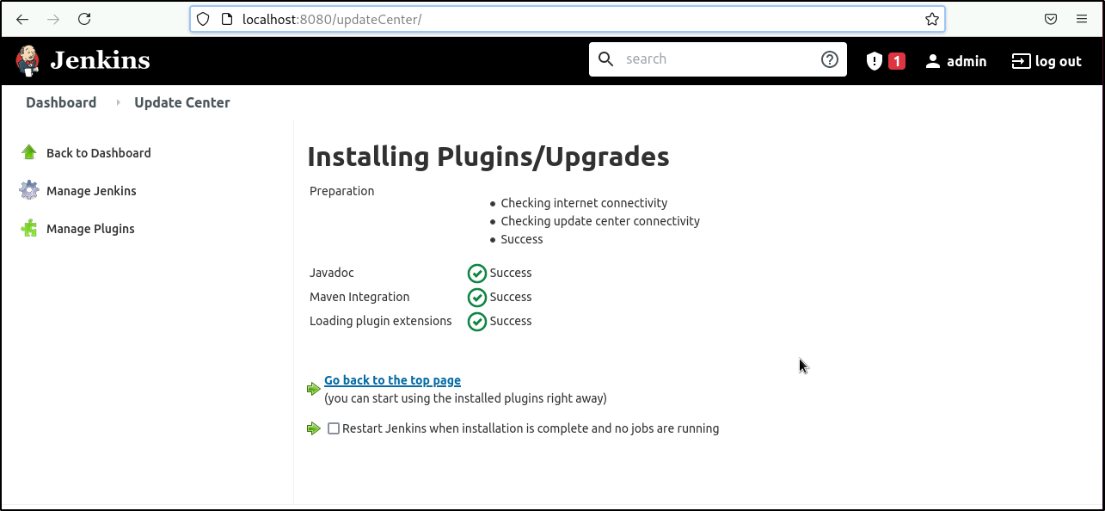
Note: Maven is already installed in your practice lab. Use the following command to check the Maven version:

mvn -version
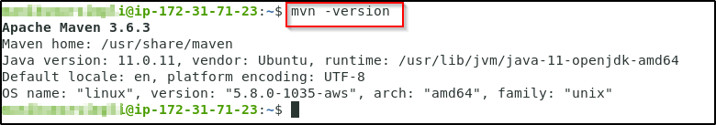
This information will help you in setting up the Global Tool Configuration.

Step 2: Setting the Global Tool Configuration

  - Go to Jenkins Dashboard, click on Manage Jenkins. From the list of options, choose Global Tool Configuration.


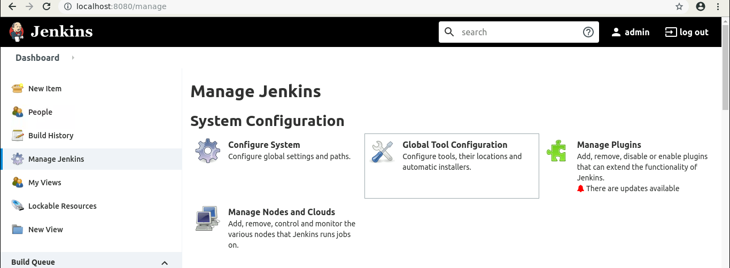

  - Click on Add JDK, and provide the Name and JAVA_HOME path. Uncheck the Install automatically checkbox.

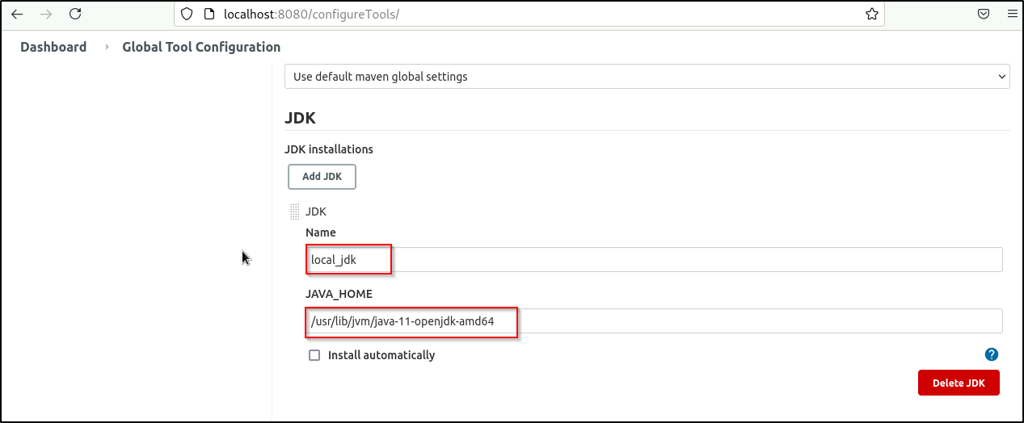

  - To configure Maven, click on Add Maven button in the Maven section, enter any Name and MAVEN_HOME path. And uncheck the Install automatically checkbox.
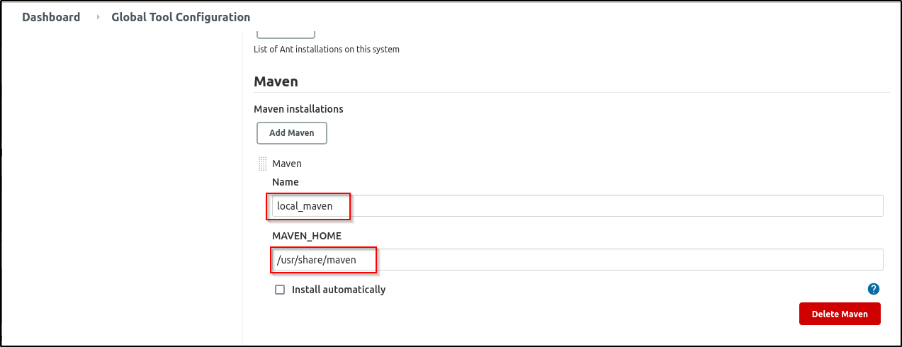

  - To configure Git, click on Add Git, and enter any Name and Path to Git executable path.
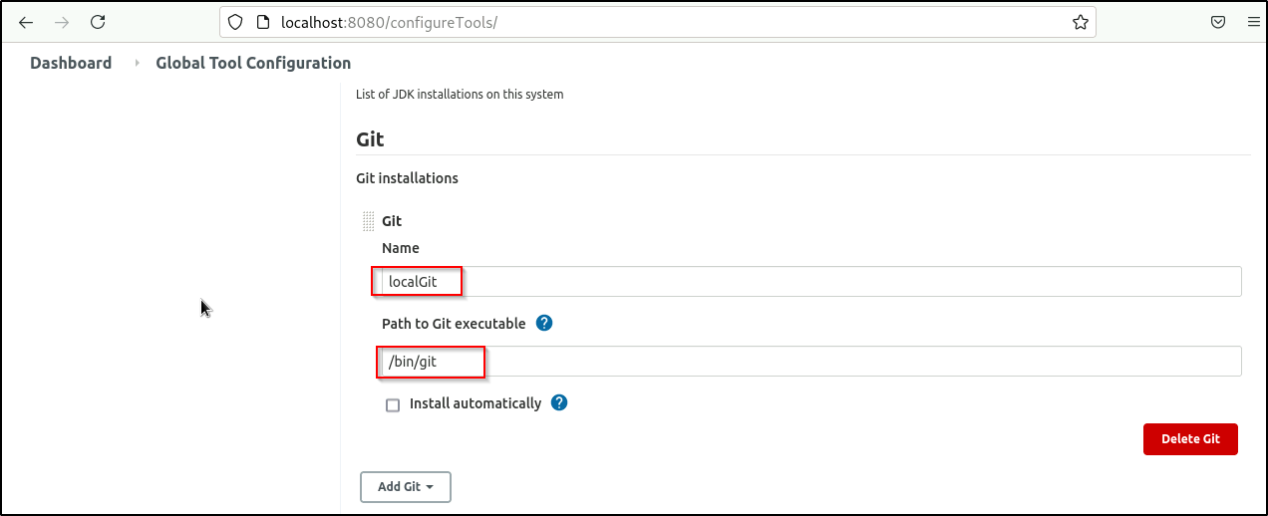
  - Click on Save.
Step 3: Forking a sample repository

  - Login to your Github account.
  - Navigate to https://github.com/jenkins-docs/simple-java-maven-app, and click on Fork.
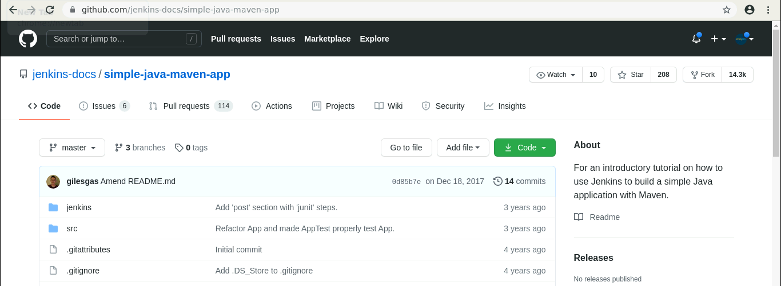

  - Open the terminal.
  - Run git clone [Forked_REPO URL] to clone the repo locally.

Step 4: Integrating Maven with Jenkins
  - Click on New Item in the Jenkins dashboard.
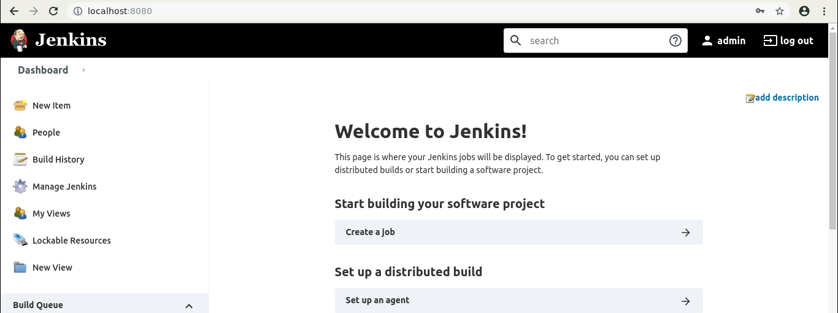

  - Enter a name for your project.
  - Select Maven project as the build job type.
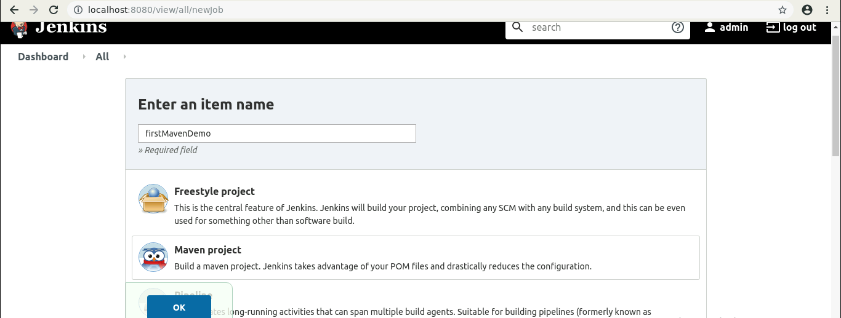

  - Click on OK.
  - Scroll down to the Source Code Management section, and select Git.
  - Enter the repository URL.
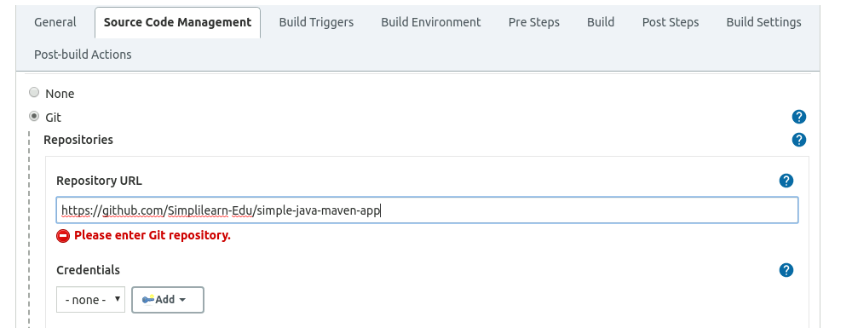

  - In the Build Triggers section, select the required option.
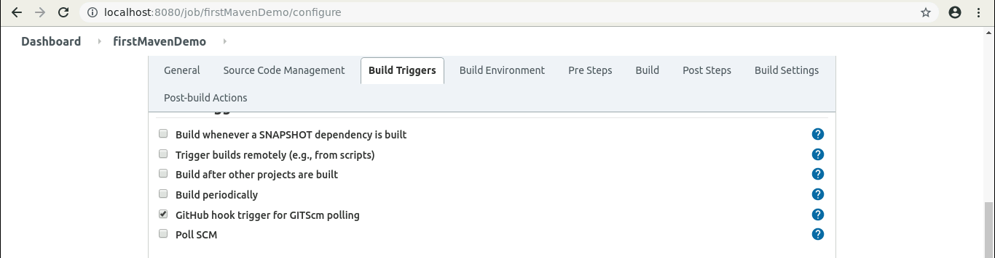

  - Click on Save.
  - Click on the Build History to view the build results.
  - Click on the Console Output to view the build logs.
